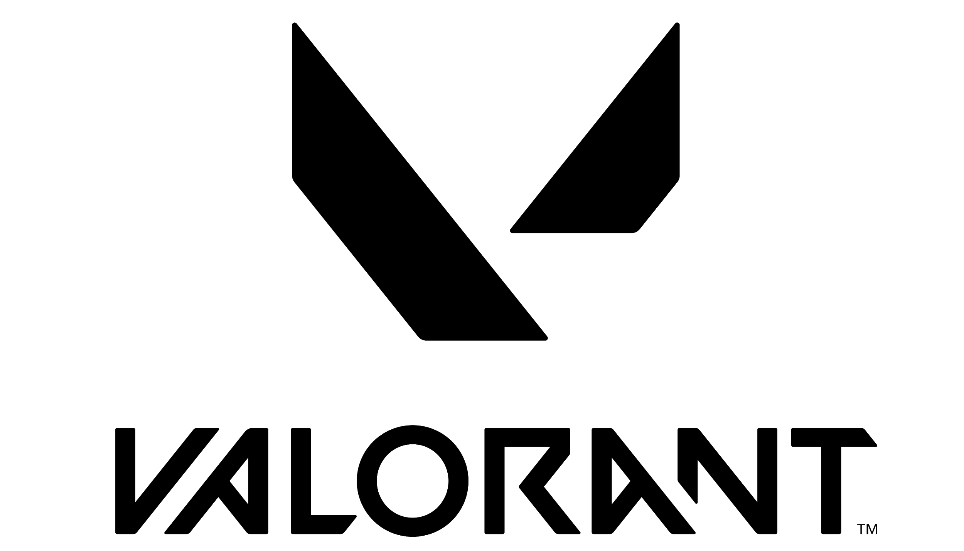

FACT SHEET - PRELUDE TO CHAOS SKIN LINE

Product Description
Forged in fire and destruction, Prelude to Chaos knows only carnage. Its thunderous roar destroys all in its warpath, whether human, demon, or the unknown.

Thematic Goals
Dark, Edgy, Sci-fi, Powerful, Chaotic

Key Features
Transformation, Animations, Visual Effects, Custom Audio, Finisher, Kill Banner, Variants, Two-Handed Sword melee

Weapons:
- Two-Handed Sword (melee)
- Vandal
- Operator
- Shorty
- Stinger

Price Tier:
XE Tier

Bundle Info:
Price: 8,700 VP
Includes:
- Blade of Chaos Sword (melee)
- Prelude to Chaos Vandal
- Prelude to Chaos Operator
- Prelude to Chaos Shorty
- Prelude to Chaos Stinger
- Prelude to Chaos gun buddy
- Prelude to Chaos spray

Levels
- Melee
  - Level 1 - Two-handed sword
  - Level 2 - Custom idle, equip, inspect, and swipes visual effects and audio
  - Variant 1 - Green/Red Variant
  - Variant 2 - Silver/Green Variant
  - Variant 3 - Blue Variant
- Guns
  - Level 1 - Custom model
  - Level 2 - Custom muzzle flash effects and firing audio
  - Level 3 - Custom idle, equip, reload, and inspect animations, visual effects, and audio
  - Level 4 - Kill Banner and Finisher
  - Variant 1 - Green/Red Variant
  - Variant 2 - Silver/Green Variant
  - Variant 3 - Blue Variant

Developer/Publisher: Riot Games

Release Date: June 22, 2022

